**SAVEETHA SCHOOL OF ENGINEERING**



**CAPSTONE PROJECT**

**E-MAIL SERVER VERIFICATION USING CISCO PACKET TRACER**

**NAME:** Dasari. Navya Sree

**REGISTER NUMBER:** 192372366

**COURSE CODE:** CSA0747

**COURSE NAME:** Computer Network for IOT

**INTRODUCTION:**

This project aims to configure a fully functional email server that facilitates sending and receiving emails within a network. An email server plays a critical role in modern communication, managing the flow of emails through protocols such as SMTP (Simple Mail Transfer Protocol) for outgoing emails, and IMAP/POP3 for incoming emails. The project focuses on setting up the network, configuring devices like routers and switches, and creating an email service using Packet Tracer’s simulation capabilities. This helps in understanding the basics of email server communication protocols (SMTP, IMAP/POP3) and network design for email systems.

**Objective:**

1. To design and configure a network setup for an email server using Cisco Packet Tracer, including a router, switch, server, and PCs.
2. To simulate the functionality of an email server using the built-in capabilities of Packet Tracer.
3. To implement key email communication protocols (SMTP for sending emails and IMAP/POP3 for receiving) in a simulated environment.
4. To configure network devices such as routers and switches to ensure proper connectivity and email transmission between clients.
5. To test the network and email configuration by simulating email traffic between the PCs and the server.
6. To troubleshoot potential issues related to the email server configuration, network setup, or device misconfigurations in Cisco Packet Tracer.

**LITERATURE REVIEW**

The email system is one of the most fundamental technologies used for communication in the modern digital era. This literature review provides a theoretical foundation for the implementation of email servers using Cisco Packet Tracer, covering the essential protocols, network design, and security mechanisms needed for effective email communication.

**METHODOLOGY**

**Software:**

- Cisco Packet Tracer

**Network Design:**

Network consist of

- 1 router

- 1 switch

- 2 PC

- 1 server

The router is connected to the server. The switch is connected to the router. Then connect the two PC’s to the switch.

**IP Address Allocation:**

**STEP 1:** Place the server. Next place the router. Connect the router to the server with the copper cross wire.

**STEP 2:** Place the switch and connect the switch to the router with copper straight-Through.

**STEP 3:** Place 2 PC’s that are connected to the switch with copper straight-Through.

**STEP 4:** Go to server and select desktop and enter server IP address - 192.168.2.2 and default gateway - 192.168.2.1

**STEP 5:** Go to router and select configure select the FastEathernet0/0 enter the IP address 192.168.1.1 and then go to FastEathernet1/0 with IP address 192.168.2.1

**STEP 6:** Go to the PC’s and select PC0 go to desktop and enter the IP address - 192.168.1.2 and enter the default gateway - 192.168.1.1

**STEP 7:** Select the PC1 go to desktop and enter the IP address - 192.168.1.3 and enter the default gateway - 192.168.1.1

**STEP 8:** Click on the server and go to the services select the EMAIL create the domain name and user setup.

**STEP 9:** Click on the PC’s go to EMAIL and select the compose and send the message to other PC.

**STEP 10:** Now you can send and receive the messages and we can give the replies for those messages.

**Protocol: - SMTP and IMAP**

* SMTP (Simple Mail Transfer Protocol) is the primary protocol used for sending emails. It handles the transmission of email messages between servers and from email clients to servers. RFC 5321 defines the standard for SMTP, and it plays a central role in ensuring reliable email delivery.
* IMAP (Internet Message Access Protocol) and POP3 (Post Office Protocol) are the two primary protocols for retrieving emails from the server. IMAP allows multiple devices to access the same inbox simultaneously, making it suitable for modern email usage patterns. POP3, on the other hand, downloads emails to the client and typically removes them from the server, making it less ideal for multi-device usage**.**

**RESULT:**

**Network Design:**

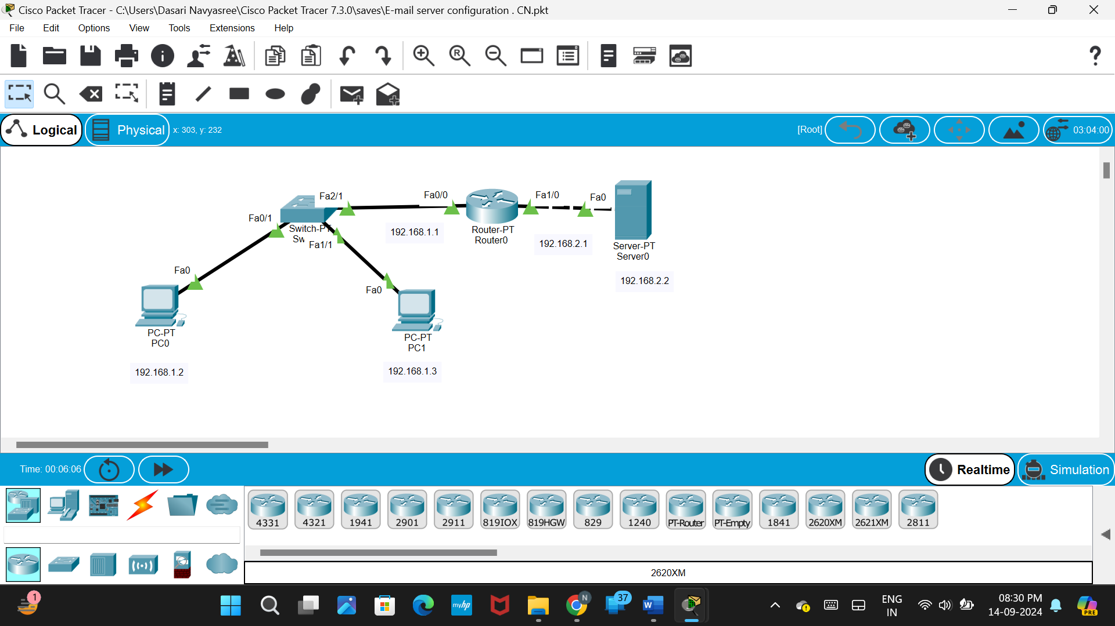

* **PC 0 -> desktop -> EMAIL**

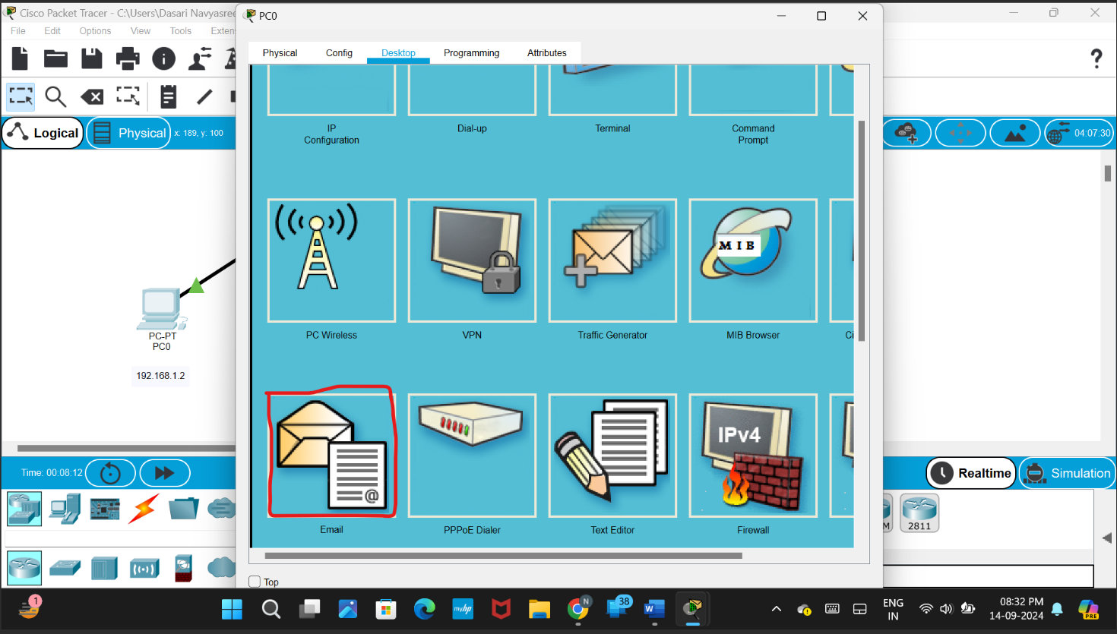

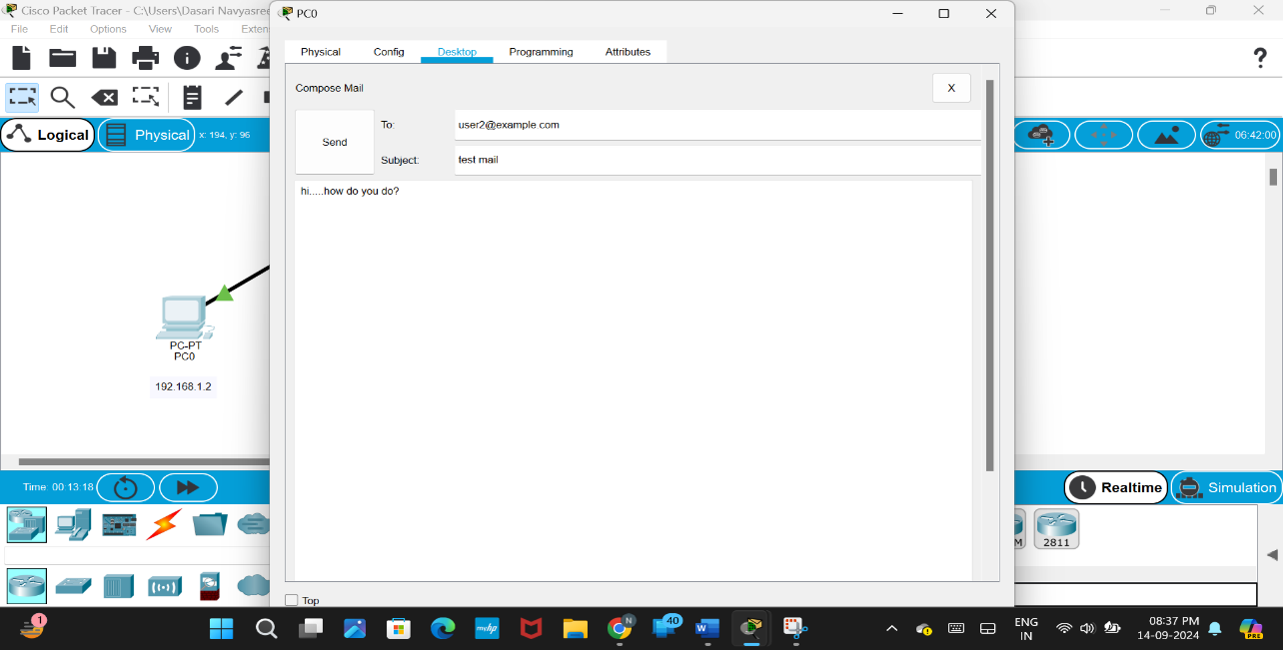

* **PC 1 -> desktop -> EMAIL**

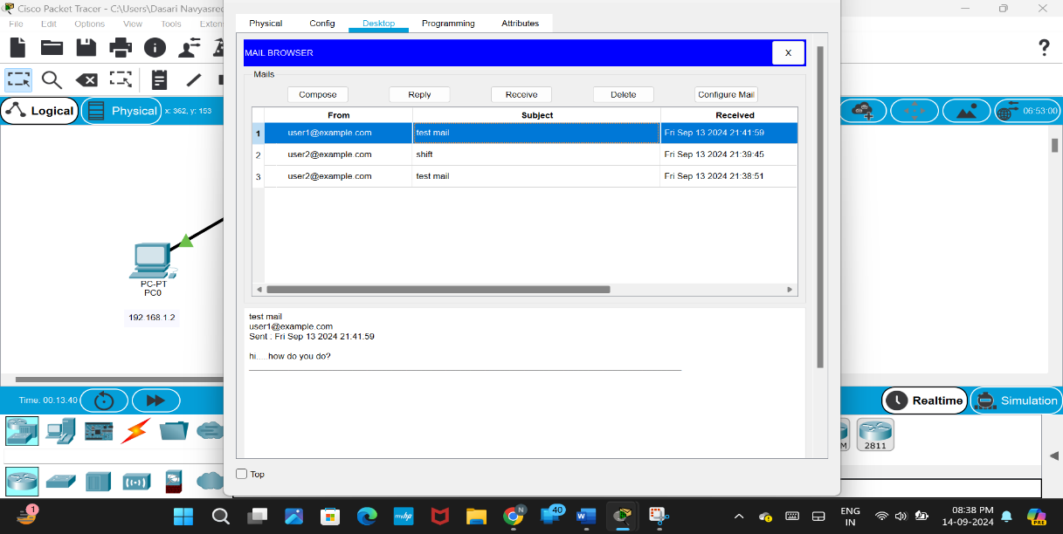

**CONCLUSION:**

The email server configuration project provides a comprehensive understanding of both network design and the essential protocols required for effective email communication. By setting up an email server in a simulated network environment using Cisco Packet Tracer, the project enables a hands-on experience in configuring routers, switches, and servers to facilitate email transmission using SMTP, IMAP, and POP3 protocols. While Packet Tracer offers limited functionality in replicating a real-world email server setup, it helps in understanding the core concepts of network connectivity, IP addressing, and email services. This project also highlights the importance of securing email communications through encryption (SSL/TLS) and implementing proper DNS configurations such as MX, SPF, and DKIM records. Overall, the project serves as a valuable stepping stone for future work in deploying and managing email systems in real-world environments using more advanced tools and technologies.

Here's a summary of what you can achieve with Cisco Packet Tracer regarding Email server configuration:

1. **Basic Network Setup:**
   * Simulate a network design with routers, switches, servers, and client PCs.
   * Configure IP addressing, subnets, and connectivity between devices.
   * Use a basic mail server simulation available within Packet Tracer.
2. **Simulating Email Protocols:**
   * Demonstrate the theoretical flow of emails using SMTP (for sending) and IMAP/POP3 (for receiving).
   * Although full email server functionality is not available, Packet Tracer shows how these protocols would operate in a network.
3. **Network Device Configuration:**
   * Set up routers and switches for email communication.
   * Configure devices to support IP connectivity for email services.
4. **Basic DNS and Email Routing:**
   * Simulate DNS settings, including MX records, for routing email between different networks or domains.
5. **Connectivity and Troubleshooting:**
   * Test network connectivity between email clients and servers using pings and trace routes.
   * Troubleshoot network and device issues in relation to email services.